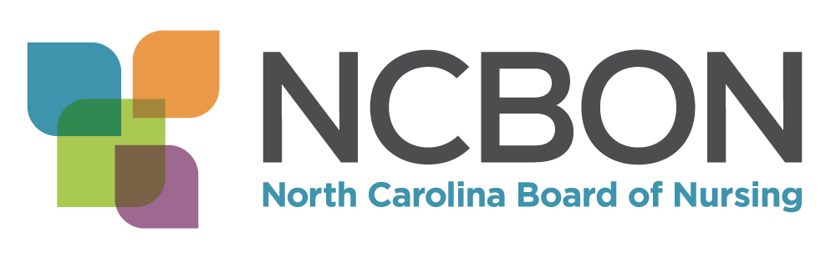 | SPEAKER REQUEST FORM  Please complete and send to:  Paulette Hampton, MA - Practice Coordinator  Fax – 919-781-9461 – ATTN: Paulette  Email – paulette@ncbon.com

Requester Contact Information
Organization Name
Contact Person Name/Title
Email
Office Phone
Cell Phone
Fax
Date/Time Information
Desired Date and Time
Street Address

Building Name

Room Number

Parking Instructions

Other specific information re location

Attendees and Logistics
Number of Attendees
Minimum of 25 licensed nurses required (APRN, RN, LPN). Five business days prior to the presentation, the NCBON may cancel said presentation if the adequate number of participants are unable to attend.

How many participants do you expect? ______
In what format would you like the requested workshop to be held? Check appropriate box below.
In-Person (Presenter comes to requesting facility to provide workshop.)
Via Webinar - (Presenter provides live interactive workshop via Teams meeting link). Once the date/time has been confirmed with the presenter, we will request a dry run to test Teams connection capability. Please have IT support available on day of the dry run and webinar to assist your facility with possible technical issues.
If in-person, we wish to request the following be available to the presenter on the day of the presentation:
- Laptop (please load PPT to laptop once emailed)
- Access to Internet (if possible)
- LCD Projector
- Microphone
- Podium
- Speaker stool or chair
- Copying and distributing handout materials for attendees (these will be sent via email)
If you are unable to provide one of the above items, please indicate said item(s) below:
Additional Notes
As of June 30, 2024, the North Carolina Board of Nursing
no longer provides contact hour credit for the offerings listed on this form.
Presentation Title/Description
Check Presentation(s) You Wish to Request (Check appropriate box(es) below:
Continuing Competence – 1 hour
Presentation is for all nurses with an active license in NC and is an overview of continuing competency requirements.

Legal Scope of Practice – 2 hours
Defines and contrasts each component of the RN and LPN scope of practice including nursing accountability for delegation of tasks to unlicensed assistive personnel. Potential violations are discussed.

Delegation: Responsibilities of the Nurse – 1 hour
Provides information about delegation that would enhance the nurse’s knowledge, skills, and application of delegation principles to ensure the provision of safe competent nursing care. Discussion includes the role and responsibilities of the nurse for delegation to unlicensed assistive personnel.

Understanding the Scope of Practice and Role of the LPN – 1 hour
Assists RNs, LPNs, and employers of nurses in understanding the LPN scope of practice.

NC Nursing Regulation Overview and Updates – 1 hour
Describes an overview of the NC Board of Nursing authority, composition, vision, function, activities, strategic initiatives, resources, and provides NCBON updates.

Prevention of Documentation and Medication Errors – 1 hour
Provides information about nursing regulatory requirements for documentation and medication administration; and best practices and strategies to prevent documentation and medication errors.

Introduction to Just Culture and NCBON Complaint Evaluation Tool – 1 hour and 30 minutes
Provides information about Just Culture concepts, role of nursing regulation in practice errors, instructions in use of NCBON CET, consultation with NCBON about practice errors, and mandatory reporting. Suggested audience is nursing leadership: director, administrator, manager, supervisor, etc.

Introduction to the NCBON Complaint Evaluation Tool – 1 hour
Provides brief information about Just Culture concepts and instructions for use of the NC Board of Nursing’s Complaint Evaluation Tool, consultation with the NCBON, and mandatory reporting. Suggested for nurses in leadership positions already familiar with Just Culture.

Overview of Nursing Practice Act Violations and Investigations – 1 hour and 30 minutes
Provides information about the five common NPA violations reported to the Board of Nursing and the five common pieces of evidence gathered during an investigation.

Newly Licensed Nurse Orientation Workshop – 3 hours
Provides newly licensed nurses with information about the functions of the NCBON, the Nursing Practice Act, Administrative Rules, common practice concerns, strategies to avoid potential violations, and available resources.
Please see information below.
HONORARIA
An honoraria of $100.00 per workshop is accepted but remains discretionary.
Please make checks payable to the North Carolina Board of Nursing – PO Box 2129 – Raleigh, NC 27602
QUESTIONS?
Please contact Paulette Hampton, MA - Practice Coordinator at paulette@ncbon.com.

